Commercial Payer Negotiated Price Variation for Imaging Services in California

ABSTRACT:
Introduction: Commercially negotiated imaging prices vary widely across insurers, yet analysis is constrained by the structure and quality of hospital price transparency data. This study examines variation in CT, MRI, and X-ray prices across major commercial payers in California hospitals and explores the role of hospital demand.
Methods: A large dataset was constructed from California hospital price-transparency files and cleaned through several preprocessing steps. Hospitals were classified into high- and low-demand groups using K-means clustering based on observable volume and imaging activity. ANOVA, Tukey HSD, two-way ANOVA, and Welch t-tests were used to assess variation across payers, procedures, and demand groups, and predictive models were applied to evaluate the relative influence of key factors.
Results: Negotiated imaging prices in California show substantial and systematic variation across insurers, modalities, and hospital demand levels. These findings highlight persistent differences in bargaining dynamics and offer insight for purchasers and policymakers seeking to understand imaging cost variation.
Conclusion: Commercial imaging prices in California show large, systematic variation across insurers despite transparency regulations. These findings highlight persistent negotiation understanding and offer insights for policymakers, purchasers, and clinics that are concerned with cost variation.
Key words: Price transparency; Negotiated rates; Imaging procedures; ANOVA; commercial insurance; pricing;

- INTRODUCTION:

The United States healthcare system combines world class clinical capability with a pricing environment that remains opaque, inconsistent, and difficult for patients to navigate. Motivated by this tension between clinical excellence and financial complexity, this study examines how negotiated prices for common imaging services vary across major payers in California.
Imaging procedures were selected as the focus of this analysis for several reasons. Imaging is foundational to medical diagnosis and frequently represents the first step in determining a patient’s condition. Despite their routine use, these services are considerably more expensive in the United States than in many other countries. As a result, investigating the pricing structure of imaging procedures provides valuable insight into the broader issue of healthcare affordability and helps identify potential sources of price variation and inefficiency.
This study utilizes hospital price transparency data sourced from the Patient Rights Advocate’s Hospital Price Files Finder. The platform provides publicly accessible pricing files compiled from hospitals across the United States in accordance with the Centers for Medicare & Medicaid Services (CMS) Hospital Price Transparency Rule. For this analysis, the dataset was restricted to hospitals located within California.
Our research focuses on examining how negotiated dollar amounts vary for common imaging procedures among four major commercial insurers Blue Cross, Cigna, Aetna, and UnitedHealthcare in California hospitals. Imaging services were grouped into three categories CT, X-ray, MRI
In the underlying files, imaging procedures are not always reported using a single code type. Some hospitals classify these procedures under CPT codes, while others list equivalent services with a HCPCS code type label.
The findings reveal substantial negotiated price variation for the same category of imaging services across payers and hospitals. Although certain drivers of this variation were explored, many determinants of payer hospital negotiations remain proprietary.
Using limited available indicators, we loosely grouped hospitals into high demand and low demand categories to see whether insurers negotiated differently with each group. A clear pattern emerges from the analysis, indicating that even the largest commercial payers have reduced negotiating power when contracting with high demand hospitals, resulting in higher negotiated imaging rates. This has meaningful implications for patients and purchasers. Higher negotiated prices often translate into increased premiums, greater coinsurance, and quicker progression toward deductibles and out of pocket maximums. Although high demand can reflect reputation or service breadth, it does not necessarily indicate superior clinical quality, and lower demand hospitals do not inherently provide lower quality care.
- DATA AND METHODS:

Diagram1 – Data Pipeline Overview
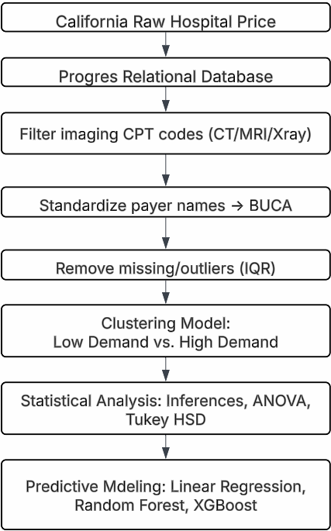
2.1 Data Cleaning:
We obtained data from roughly 200 hospitals, each reporting payer specific negotiated prices for inpatient and outpatient services. The files varied considerably in structure; many hospitals reported prices in wide formats in which each payer contract appeared as a separate column.

To support consistent analysis across institutions, we converted all files into a standardized long format so that each row corresponded to a single payer procedure price. The combined dataset was then imported into a relational database with over 100 million pricing records. Because our study focuses on diagnostic imaging, we limited the analytic sample to procedures associated with CT, MRI, and X-ray services, identified using a curated set of imaging related CPT codes. Our data is summarized into approximately 3 million records, which is sufficient for analysis.

2.2 Data Standardization
A key preprocessing step involved standardizing payer names, as hospitals reported insurer information using highly inconsistent labels, abbreviations, plan descriptions, and naming variations that often referred to the same underlying organization. To improve comparability across hospitals, we converted all payer identifiers into a uniform format, removed unnecessary characters, normalized common abbreviations, and grouped related subsidiaries and plan types under unified payer families. This Standardization process collapsed from many fragmented payer labels into four major commercial groups: Aetna, Blue Cross, Cigna, and UnitedHealthcare.

2.3 Imputation and Data Cleaning
Missing negotiated price values were common in the raw transparency files, largely reflecting incomplete hospital reporting or the absence of contracted rates for specific payer procedure pairs. In the consolidated imaging dataset, roughly 13% of records lacked a valid negotiated amount. Because negotiated prices are the central outcome of interest, retaining entries with missing values would add little analytical value and could bias comparisons across payers. We considered imputation strategies, but such methods risk creating artificial patterns in a dataset where prices stem from negotiated agreements rather than random variation. Given the substantial size of the remaining sample, we elected to exclude all records without a reported negotiated price to ensure that our analysis relied solely on actual contract rates.
After removing missing entries, the negotiated price distribution displayed strong skewness and heavy tails, indicating the presence of extreme values that could distort both descriptive statistics and inference. Because statistical testing relies on approximate normality and stable variance across groups, retaining these extreme observations would reduce the validity of the results. To address this, we applied an interquartile range-based filter to remove unusually high and low values. This produced a more symmetrical and stable distribution that is better suited for statistical testing and provides more reliability for analyzing negotiated price differences.

2.4 Statistical Analysis
We first computed descriptive statistics for the full sample and for each imaging category (CT, MRI, and X-ray) to characterize overall price patterns. After confirming that the cleaned dataset exhibited more stable and less skewed distributions, we applied one way and two-way ANOVA tests to assess whether mean negotiated prices varied across payers and procedure types. We then conducted Tukey HSD tests to identify which specific groups differed significantly from one another. Together, these analyses provided a structured approach for comparing pricing differences across insurers and imaging services.

2.5 Clustering Model
We estimated hospital demand using an unsupervised learning approach. For each hospital, we constructed a feature set that included total service volume, the number of distinct CPT codes, the number of unique payers, and the volume of CT, MRI, and X-ray procedures. After standardizing these features, we applied a K-means clustering model with two clusters. The cluster with the highest overall activity was classified as the high-demand group, while the other was labeled with low demand. This data-driven classification was then used to examine whether negotiated prices differed systematically across hospitals with varying levels of service demand and bargaining strength.

2.6 Predictive Model
A predictive modeling step was included to assess how much variation in negotiated prices could be explained by payer group, imaging category, care setting, and hospital demand level. The negotiated dollar amount was log-transformed to reduce skew, and all categorical variables were converted to one hot encoding. Three models were evaluated, including linear regression, random forest, and XGBoost, to compare a standard parametric approach with more flexible machine learning methods. Model performance was assessed using R squared in log price space and mean absolute error in dollars. For interpretability, feature importance from the tree-based models was grouped back into the original predictor categories.
Table 1 – Distribution of top 10 common procedures across California hospitals
CPT | Description | Type | Count | Mean | Std_Dev | Min | Max | IQR
73200 | CT upper extremity without contrast | CT | 25881 | 1287.77 | 1781.88 | 1.42 | 16417.50 | 158.57–2040.30
73201 | CT upper extremity with contrast | CT | 23412 | 1661.59 | 2150.84 | 1.64 | 18693.54 | 287.78–2803.62
73700 | CT lower extremity without contrast | CT | 31992 | 1474.86 | 2115.10 | 1.42 | 16594.38 | 141.23–2293.09
73701 | CT lower extremity with contrast | CT | 25234 | 1698.90 | 2303.72 | 1.64 | 20751.39 | 226.19–2894.40
73702 | CT lower extremity without then with contrast | CT | 23005 | 1811.18 | 2603.79 | 1.72 | 25927.38 | 226.19–3004.08
73723 | MRI joint lower extremity without contrast | MRI | 22190 | 2590.78 | 3375.90 | 1.85 | 35228.25 | 449.90–4532.00
76882 | US limited extremity | US | 22553 | 354.27 | 455.65 | 0.69 | 6193.00 | 47.07–492.00
76942 | US needle placement | US | 51245 | 518.89 | 754.02 | 0.90 | 12062.00 | 60.18–836.50
77065 | Mammo diagnostic unilateral | XRay | 30826 | 382.64 | 361.85 | 1.16 | 2239.92 | 136.00–556.78
77067 | Mammo screening bilateral | XRay | 23585 | 345.23 | 308.55 | 1.09 | 2403.63 | 119.90–560

Table 2 – Price distribution of 4 payers across 3 imaging procedure groups
Payer | Group | Count | Mean ($) | Median ($) | Std Dev ($) | Skewness | Kurtosis
Aetna | CT | 19,596 | 2,119.64 | 1,646.28 | 1,866.80 | 0.75 | −0.30
 | X-ray | 38,523 | 689.20 | 509.20 | 669.84 | 1.05 | 0.22
 | MRI | 16,205 | 2,779.46 | 2,523.89 | 2,219.28 | 0.58 | −0.49
Blue Cross | CT | 78,853 | 1,606.97 | 617.00 | 1,794.55 | 0.97 | −0.41
 | X-ray | 136,347 | 497.76 | 217.99 | 630.80 | 1.67 | 1.99
 | MRI | 66,444 | 1,915.04 | 909.09 | 1,970.48 | 0.86 | −0.38
Cigna | CT | 15,081 | 2,130.39 | 1,646.28 | 2,051.97 | 0.90 | −0.26
 | X-ray | 24,187 | 587.01 | 494.40 | 591.20 | 1.25 | 1.07
 | MRI | 12,472 | 2,766.60 | 2,221.00 | 2,504.33 | 0.73 | −0.45
UnitedHealthcare | CT | 46,205 | 1,354.60 | 295.90 | 1,669.00 | 1.33 | 0.89
 | X-ray | 71,356 | 407.51 | 175.13 | 511.94 | 1.86 | 3.38
 | MRI | 38,101 | 1,555.80 | 499.75 | 1,894.39 | 1.45 | 1.30

- RESULT
Table 3 – Statistical Summary among Payers
Payer | Count | Mean | Std. | 95% CI
Aetna | 95,595 | 1033.51 | 1065.82 | 1026.7 – 1040.27
Blue Cross | 373,279 | 712.60 | 943.11 | 709.57 – 715.63
Cigna | 64,603 | 924.18 | 1014.46 | 916.36 – 932.01
United  Healthcare | 217,058 | 664.59 | 905.34 | 660.78 – 668.40

There is clear and meaningful variation in negotiated hospital prices across major commercial payers. Aetna consistently pays hospitals the highest rates, followed by Cigna, while Blue Cross and UnitedHealth Care pay much lower amounts for the same services. The size of the gap between the highest and lowest paying insurers is large, and the confidence intervals are narrow, showing that these differences are real and not due to random variation in the data.
Having shown that negotiated prices differ widely across insurers, we will next examine whether similar patterns appear across major procedure categories. To do this, we summarize negotiated rates for CT, MRI, and X-ray services to assess how pricing varies by group.

Figure 1 – Negotiated Dollar Amounts by Payer
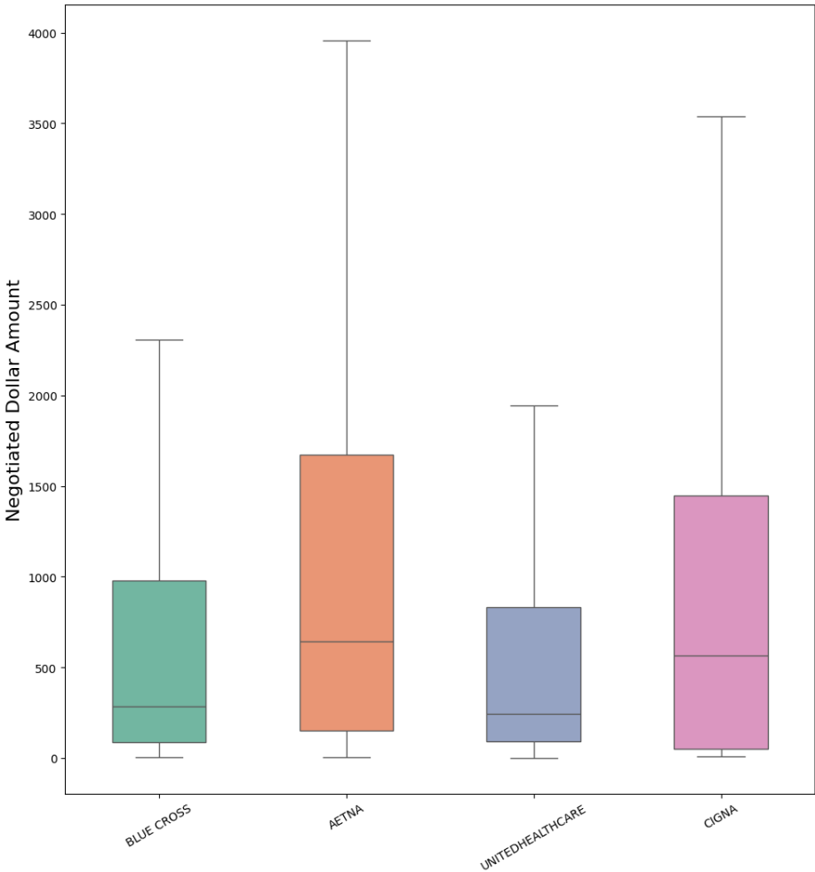

The pricing patterns show a clear picture across imaging types. MRI has the highest negotiated rates, with a mean of $2,993.34 and a median of $2,651.15, followed by CT scans with a mean of $2,663.77 and a median of $1,805.37.

Table 4 – Statistical Summary between Procedure Types
Group | Count | Mean ($) | Median ($) | Std ($) | IQR ($)
CT | 90,776 | 2,663.77 | 1,805.37 | 2,524 | 298.43 – 4,550
MRI | 78,991 | 2,993.34 | 2,651.15 | 2,532 | 485.26 – 4,650
X-ray | 224,402 | 1,195.73 | 914.39 | 1,180 | 158.92 – 1,738

X-ray procedures are substantially less expensive, with a mean of $1,195.73 and a median of $914.39, indicating that X-rays cost less than half of CT or MRI services on average. These differences across various procedures confirm that hospitals negotiate distinctly higher prices for more advanced imaging technologies.

Figure 2 – Negotiated Dollar Amounts by Procedure Group
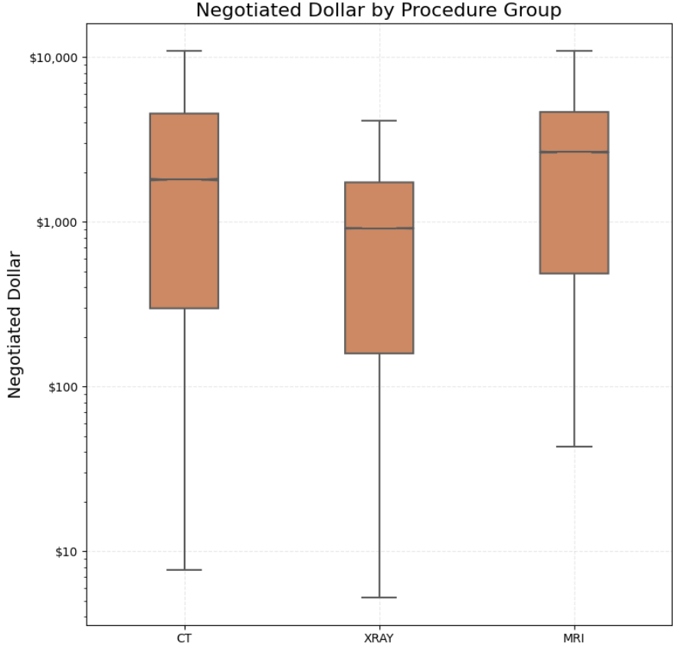

The IQR ranges show much greater price variability for CT and MRI than for X-rays. CT negotiated prices span $298.43–$4,550.00, and MRI spans $485.26–$4,650.00, each reflecting spreads of more than $4,000 within the middle of the distribution. In contrast, X-rays show a narrower IQR of $158.92–$1,737.99, indicating more consistent pricing. This pattern is reinforced by the higher standard deviations for CT ($2,524.62) and MRI ($2,532.69) compared with X-rays ($1,180.80), confirming that advanced imaging exhibits far greater variation in negotiated rates. That can be explained by complication of the treatment, which requires a generally higher cost.

Figure 3 – Mean Comparison Heatmap
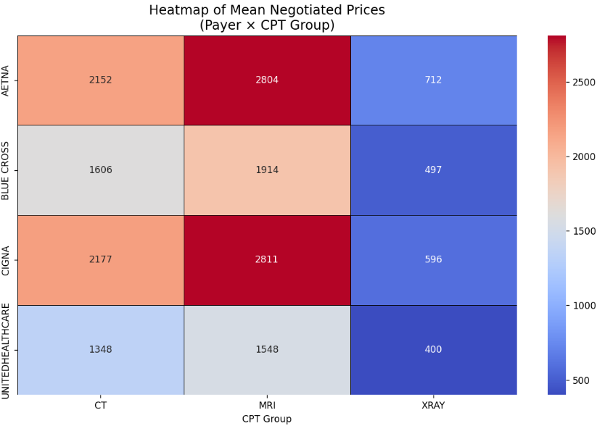
The heatmap shows that negotiated prices differ sharply across both payers and CPT groups. MRI procedures are the highest price across all insurers (ranging from $1,548 at UnitedHealthcare to $2,811 at Cigna), followed by CT scans (from $1,348 to $2,177), while X-rays remain the least expensive (from $400 to $712). Aetna and Cigna consistently pay the highest amounts, whereas Blue Cross and especially UnitedHealthcare negotiate at much lower levels. Building on this, the two-way ANOVA further shows a significant interaction between payer and CPT group, indicating that pricing differences are not only driven by the payer or procedure alone but by the combination of both factors.

The two-way ANOVA shows that both payer and CPT groups have very strong and significant effects on negotiated dollar amounts. The F-values are extremely large for F = 4500 for payer indicating these factors to explain a substantial portion of price variation. The interaction term is also significant (F = 885), meaning the effect of payer varies depending on the CPT category. All p-values are effectively less than 0,001, confirming evidence that negotiated prices differ across payers, across CPT groups, and in how these two factors interact.
The Tukey HSD metric shows that every pairwise comparison between payers is statistically significant at the 0.01 level. The size of the differences is meaningful. It shows that on average, AETNA negotiates $321 less than Blue Cross, $109 less than Cigna, and $369 less than UnitedHealthcare. Meanwhile, Blue Cross pays $212 more than Cigna and $48 more than UnitedHealthcare. All confidence intervals exclude zero, confirming actual differences in payer pricing.

Figure 4 – Mean Negotiated Dollar among Procedures and Payers
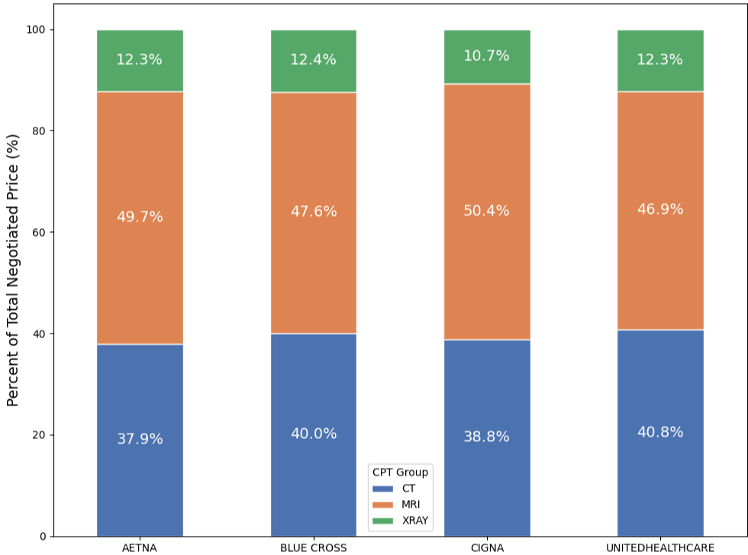

The K means clustering algorithm separated hospitals into two clear demand groups, with 75% classified as high demand and 25% classified as low demand. This split indicates that most hospitals in the dataset operate with larger service volumes, while a smaller portion handles substantially fewer procedures. These demand groups reflect meaningful differences in hospital activity levels and provide an important predictor for explaining variation in negotiated prices in the models.
The predictive models were used to assess how well the selected variables explained variation in negotiated prices. Across the three supervised learning models tested, predictive performance was similar, with R squared values near 0.30 in log price space and mean absolute errors of about 1,100 dollars.

Figure 5 – Negotiated Dollar between High Demand and Low Demand Hospitals
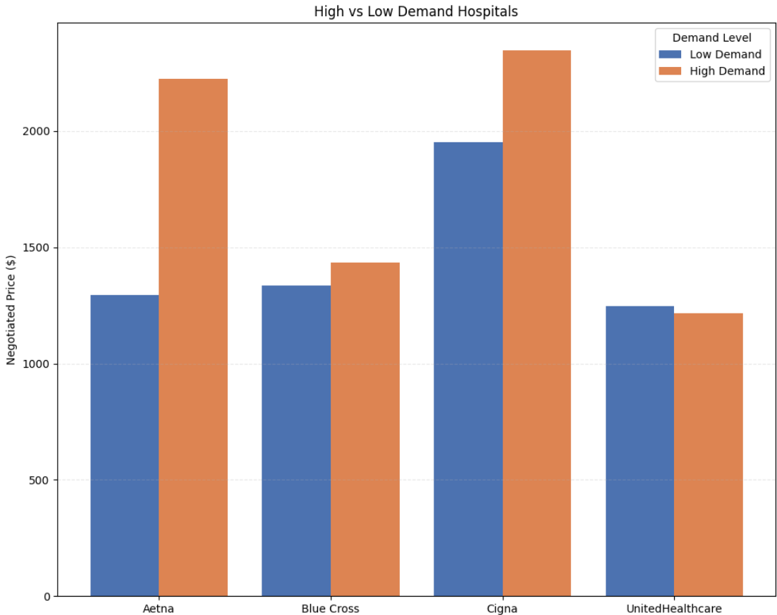

These results show that available factors explain a meaningful portion of price variation, which is notable because negotiated prices are influenced by contract terms and bargaining strategies that are not visible in transparency files. The demand hospital groups also improved model fit, which supports the idea that the earlier clustering captured real differences in hospital pricing behavior.

Table 5 – Preditive Model Result on Negotiated Price
Model | R² | MAE ($)
XG Boost | 0.306 | 1,091.95
Linear Regression | 0.297 | 1,105.37
Random Forest | 0.304 | 1,092.00

- DISCUSSION
Our analysis shows that negotiated imaging prices vary systematically by procedures, setting, payer, and hospital demand level. CT and MRI command much higher prices than X-ray. High demand hospitals consistently receive higher negotiated amounts across payers, which suggests an advantage in bargaining rather than random variation. This pattern aligns with the idea that facilities with higher volumes and broader service capacity hold a stronger negotiating position in commercial markets.
Payer differences were also evident, with Aetna and Cigna paying higher rates on average. Higher prices likely reflect weaker leverage when contracting with hospitals that hold dominant positions in the industry. UnitedHealthcare and Blue Cross generally pay lower negotiated amounts, which may indicate stronger payer-side bargaining strategies or narrower networks that give them more leverage. Overall, the results point toward an imbalance in negotiation strength that depends heavily on the structure of the local market and the importance of specific hospitals to payer networks.
Predictive modeling reinforces these insights. Setting and procedures explain the largest share of price variation, while demand level contributes meaningfully but to a smaller degree. Payer effects remain present but comparatively limited once service and hospital characteristics are considered. This suggests that structural features of the service and the competitive position of the hospital shape negotiated prices more than the insurer’s identity alone.
The interpretation of these findings should be viewed considering certain limitations. Missing or incomplete data in hospital transparency files required the removal of some payer–procedure combinations, and outlier cleaning may have excluded extreme prices that still occur in practice. This study has other limitations. The dataset does not capture many elements that influence negotiated rates, so our analysis was restricted to the limited set of observable factors available. The demand classification is based on observable indicators present in the data, and while these measures capture important aspects of hospital activity, they may not represent the full complexity of hospital market position. Within these constraints, we used the best information available to construct meaningful variables, and the results still provide a clear picture of how negotiated imaging prices vary across hospitals and payers.

REFERENCES
- American Medical Association. (n.d.). Current Procedural Terminology (CPT) codes. https://www.ama-assn.org/topics/cpt-codes
- Centers for Medicare & Medicaid Services. (n.d.). Physician Fee Schedule (PFS) relative value files. https://www.cms.gov/medicare/payment/fee-schedules/physician/pfs-relative-value-files
- EVHC. (n.d.). Reference-based pricing revealed. Retrieved, from https://evhc.com
- Jiang, J. X., Makary, M. A., & Bai, G. (2022). Commercial negotiated prices for CMS-specified shoppable radiology services in U.S. hospitals. Radiology, 302(3), 622–624. https://doi.org/10.1148/radiol.2021211948
- Patient Rights Advocate. (n.d.). Hospital price transparency files. https://hospitalpricingfiles.org
- Philips, A. P., & Whaley, C. (2025). Commercial price variation for common imaging studies. Health Affairs Scholar, 3(5), qxaf092. https://doi.org/10.1093/haschl/qxaf092

